2020.04.25.

Information -
Online mentoring service

( www.munkatanacsadas.maltai.hu )

- Job placement process
  - Who are we looking for?
We support jobseekers and unemployed people with a registered address or living in Budapest and the surrounding area, or looking for a job in the area, mainly through an online job counselling service, but also by phone. We welcome their applications.

  - How can we help?
If you decide to take advantage of the Hungarian Maltese Charity Service's "Online Labour Market Mentoring", we welcome your application via the form at www.munkatanacsadas.maltai.hu. Within 1 week of your application, our mentors will contact you through the contact details you provided. We will support you preparing for your job searching. We can also provide a telephone contact in case you need support to complete the online form. Completing the form means you want to request online mentoring. Telephone support will therefore help you to complete this form.
The service is coordinated by the Malta Care Non-Profit Ltd. and all rights are owned by the Non-Profit Ltd.

  - Who are we in contact with?
We are in contact with employer partners, job search service providers and experts. Upon a request, we will be happy to forward your contact details to these partners. We can only share your contact details if you give us your written consent.
  - Our colleagues.
Our colleagues who provide the mentoring service have the appropriate training and have been working in the same field for many years. Incorpora Hungary and the Hungarian Charity Service of the Order of Malta Association,

2020.04.25.

and employees of the Malta Care Nonprofit Ltd. work in the mentoring and dispatcher positions.
- Career advice
  - Why is it useful?
If you have lost your job during the crisis and do not know where to start your job search, we can help you with guidance. With our mentors, you can get an overview of the current job market situation, get oriented, get career advice and we can help you make your CV competitive in both content and format. Our service is free of charge for those interested.
  - Our colleagues.
Our colleagues have been working for many years to prepare disadvantaged people who are unemployed for the labour market. They are familiar with the difficulties faced by disadvantaged people and can provide a value-added service that you can only get from an organisation working with this clientele.

- Curriculum vitae form

You can request a job mentoring session by filling in the following form at www.munkatanacsadasmaltai.hu:
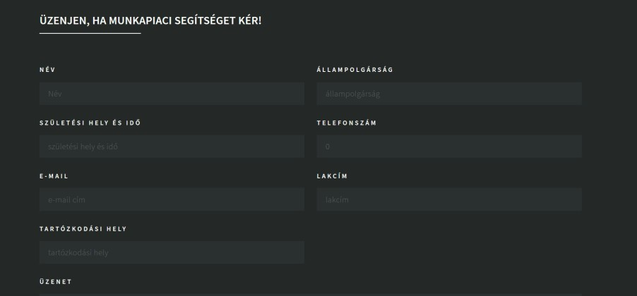

- Update data
Mentoring can also be specifically job placement. If you provide your contact details in the form above, our advisors can contact you at the contact details provided in case of a specific job offer. If you apply for a specific job vacancy, you may be required to provide additional personal data relevant to the job in question.
We are not responsible for the processing of any special data that we have obtained without your explicit request (e.g. in the CV uploaded during online registration).

2020.04.25.

responsibility.

- What makes a good CV?

A good CV is a good way to show what experience and qualifications you have. If you already have a CV and you send it to mentors during the work process, please do not include any special information (“Info tv”3 § 3. Any data falling within the special categories of personal data, i.e. personal data revealing racial or ethnic origin, political opinions, religious or philosophical beliefs, trade-union membership, genetic data, biometric data for the purpose of uniquely identifying natural persons, health data and personal data concerning the sex life or sexual orientation of natural persons.

- Other useful information

When you visit our website (www.munkatanacsadas.maltai.hu ), our system automatically records the IP address of your computer, the time of the start of the visit and, in some cases, depending on the computer's settings, the type of browser and operating system, as well as the geographical location that can be determined on the basis of the IP address. The data thus recorded cannot be linked to other personal data. The data are processed for statistical purposes only.
- We reserve the right to place a data file (cookie) on your computer.

